Using COOL 3D as an Authoring Environment

A cost effective graphic authoring companion for ChyTV would be Ulead’s COOL 3D Production Studio. Using this software you can create three-dimensional graphics and animations for use directly on the ChyTV. This guide will show you how to use COOL 3D to create three-dimensional text and then animate it.

Before getting started make sure you have Ulead COOL 3D Production Studio installed. You will need a slight knowledge of three-dimensional terms and techniques.

Start by loading COOL 3D. When the program begins you’ll be given a document window where you will be working. This window will default to 320 pixels wide by 240 pixels high. While working on the text it would help to increase the document size (you can always change it later). From the application’s menu, select Project and then Dimensions. When the dimensions window appears, change the width to 640 pixels and the height to 480 pixels. Click OK and the document will be resized.

Creating 3D Text
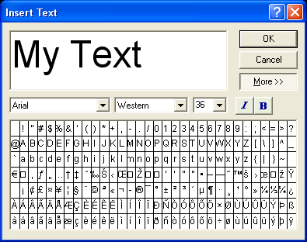

Figure 1
Insert Text dialog window
The simplest way to create three-dimensional text with COOL 3D is to simply write it out. Using the Insert Text function you can create a letter, word or phrase for animation and other effects. Open a new document and click the Insert Text button, the top button on the left toolbar. You should see a screen similar to that of Figure 1.

You have complete control over the font attributes including font name, locale, size, italic and bold. If you expand the dialog by clicking the More >> button, you will have a list of special characters that you could normally not type out on a keyboard.

Remember that most fonts have special characters, and other fonts are solely made up of special characters. If it is ever the case you need a symbol, be sure to check out the special character fonts such as Wingdings or Arrows.

Type your phrase into the text box on top and make font adjustments. When you are finished, click the OK button. Your text should appear somewhat extruded in the document window. See Figure 2.

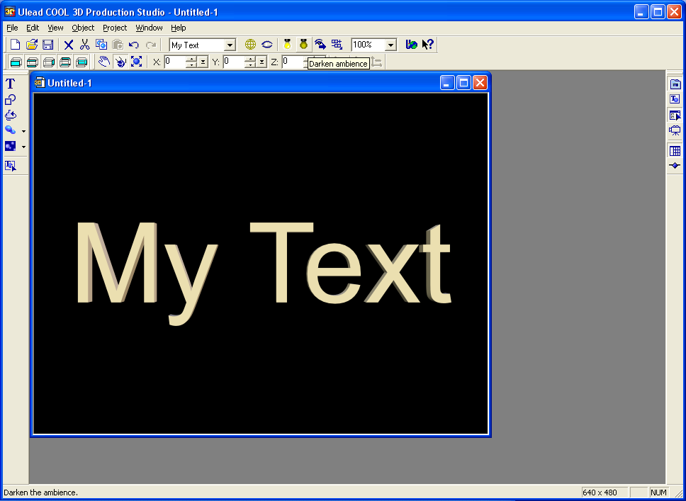

Figure 2
3D text created with Insert Text

In the next few sections you will learn about giving the text a variety of effects.

Rounding the Edges

Sometimes your text could look more three-dimensional with the help of rounded edges. You can create these edges using the bevel feature. We are now going to apply a round bevel to our text.

From the Attribute Panel, select Bevel from the drop down list. The contents of the Attribute Panel should change, reflecting various parameters for creating a bevel on the currently selected object, which is our text. In the bevel mode section you will find a dropdown containing all types of beveling effects. For our purposes we’re going to select Round.

You should notice a change in the text in the document canvas. It should have gotten more of a shine around its edges. This is fine, but we’re going to further modify it in hopes to pronounce the round edges a bit more. Play around with the parameters for extrusion, weight, border, depth and precision so that you can see how the text is affected. When you are ready, set the values to the following:

Extrusion: 50
Weight: 15
Border: 5
Depth: 50
Precision: 3
You should get something along the lines of Figure 3. While retaining the same settings on the bevel parameters, experiment with changing the bevel mode. Some of the more interesting bevel modes are Board, Hollow and Imprint.


Figure 3
Text with bevel application

There are also presets provided by COOL 3D. If you click on the View Thumbnails button inside of the Attribute Panel, a window named EasyPalette should display the presets as thumbnails. To apply these presets, simply double click on them with the text object selected.

Changing the Text Color


Figure 4
Text after color change to green
Altering the text color is relatively simple. From the Attribute Panel, select Color from the dropdown list. You will be presented with two sections, Surface Color and Specular Color.

Under Surface Color you can either choose a color by clicking the colored button, or you can adjust the Brightness, Saturation and Hue values to a color you need. We’re going to change the color of the text to green. Click on the colored button in the Surface Color section. When the dialog comes up, specify a green color with red, green and blue values of 0, 128 and 0 respectively. The text should now resemble Figure 4.

We will not be using Specular Color in this tutorial, so there’s no need to modify these values. Specular color refers to the shine color of an object. When a white light is shining on a 3D object, the color that is reflected off the shiny parts is specified by the specular color. If you were to change the text back to a white surface color and then applied a blue specular color you would see a hint of blue along the edges that reflect more light than the surface. Applying a low luster level will make this effect more prevalent.

Applying a Texture to the Text

If a solid color is not exactly what you want on your text, you have the option of applying a bitmapped texture onto the face of your text. With COOL 3D Production Studio you also have an option for applying a video to the face of the text! Let’s examine the features available to texture mapping.
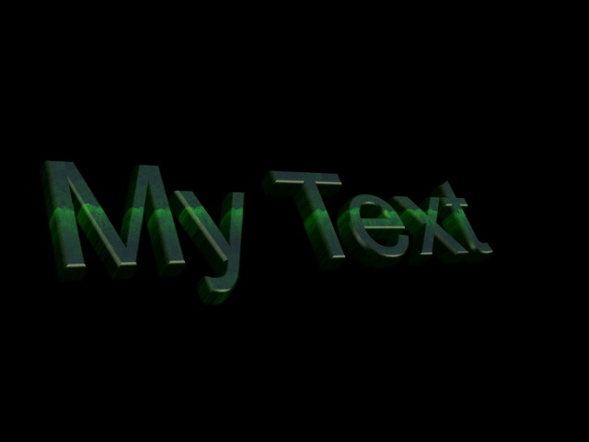

Figure 5
Texture mapped text with overlay

The first thing to do is specify which texture you want to apply to the object. To do this, make sure the Image radio button is selected, and click the Use checkbox under the Texture section. A file dialog will appear asking you to locate the texture to use on your text. The file this tutorial uses is called winter.jpg and is located in the My Pictures folder as one of the default images that ships with Windows XP. If you do not have this file, use a different one for now.

After you select your texture you will notice that the text object now has the texture mapped over it but the green tint is coming through the image. This is because the default texture map setting is as an overlay, exposing the color attributes of the text object. See Figure 5 for this effect.


Figure 6
Texture mapped text with no overlay

This isn’t very attractive in our case, so we will now turn off this overlay feature. In the Texture section of the Attribute Panel, there will be a button labeled Show texture color only. Click this button and you will notice the text object will change and resemble something like Figure 6.

The default mapping of the texture may not suit your needs. If this is the case you can modify the way it was mapped onto the object. The Wrap section specifies the overall orientation of the texture map on the object. By default it is set to Flat, which could be thought of as laying the image directly on top of the text. Other modes, such as Sphere or Cylindrical change the mapping method so that the rectangular image would not distort when applied around a sphere or cylinder object. Experimenting with these settings on our text may not give desired results, but keep these features in mind when you create other types of 3D objects.

The last feature of texture mapping that we’ll use resides in the Mapping section. The mapping section is responsible for positioning, sizing and rotating the image on your object. Figure 6 showed the text with white snow caps running through it. Let’s move these snow caps to the top of the object.
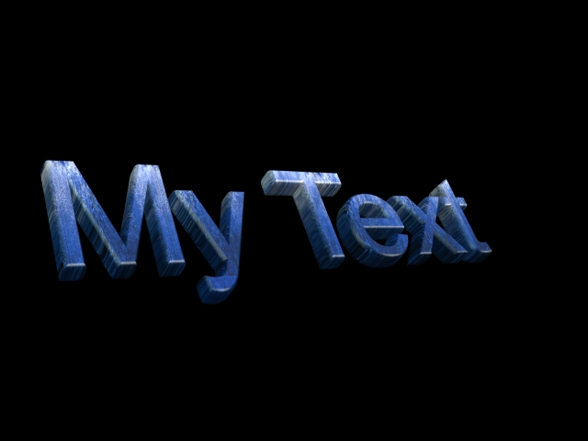

Figure 7
Snow capped text
In the Mapping section, click on the Position texture button (the first button on the left). Doing this will enable the controls labeled X, Y and Z. Change these value to X = 50, Y = 174, Z = 0. Click on the Scale texture button (first button on the right). Change these values to X = 100, Y = 40. Now the text appears as if it has been left out in a snow storm, see Figure 7.

Animating the Text

Until now you’ve gathered enough skills to create text and apply a variety of effects to it. While having your message stand still may serve its purpose, you are more likely to grab the attention of the viewer if you animate the text in some fashion. From here out we’re going to create a small animation that could be used as part of a ChyTV weather presentation.

First thing to do is to change the text to read something else. Instead of having to create a new text object, you can modify the one we already made. To change the text, you could click Object from the application’s menu and then select Edit Obejct, or you could press the F4 key. When you get back into the text editor, change the text to read “COLD” and apply a bold effect to it. The new object should resemble that of Figure 8.
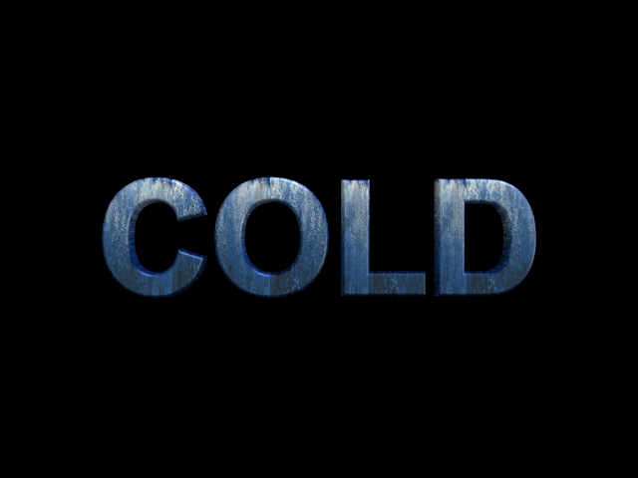

Figure 8
COLD text for animating

There are a few ways to animate this text. If you want an animation of the position, size or orientation of the text, you would want to make use of the Timeline panel. The timeline shows the distinct changes in your object over a period of time (referred to as frames). A black square or black circle in one of these frame spots represents one of these changes. Each animation has a start frame, an end frame and a series of keyframes in between. All the work we’ve done so far has been on the first frame. Click on the last frame, frame 10, on the timeline. See Figure 9.
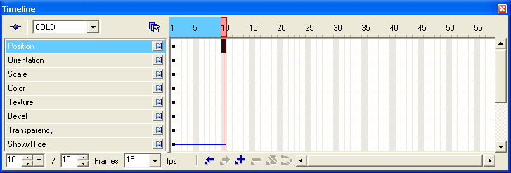

Figure 9
Animation timeline

On the bottom of the Timeline panel is a button that resembles a plus sign ( + ). Click this button to insert a new keyframe. Now a black circle should be in the timeline under the Position layer for frame 10. Click on the first frame again. Using the position modifier in the application’s top toolbar, change the Z value to 10000. The text will move far away from the camera, as is seen in Figure 10.

You have just created a basic animation. The first frame starts with the text at Z position 10000. As the timeline continues to frame 10, the text will move closer and closer to the original position, Z = 0. This is because we inserted a keyframe at frame 10 for the position layer. The way COOL 3D animates is by taking the start frame properties of an object and interpolating movements, color cycling or any other property changes until it reaches the values specified in the next keyframe on the timeline. Go to the Navigation toolbar and click the play button to see for yourself. The text should come at the camera from far away, over the span of 10 frames.
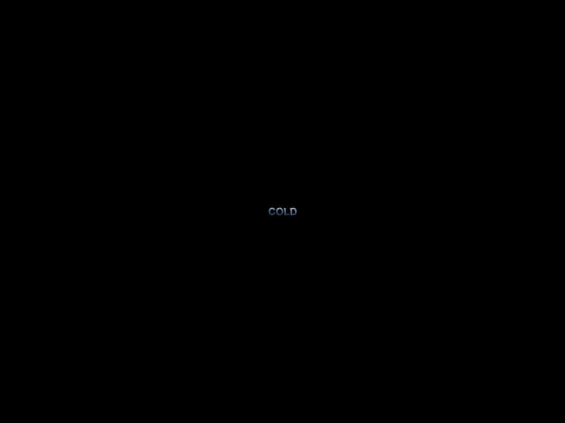

Figure 10
Text at Z = 10000

Timeline Management

Right now the animation will play out relatively choppy over a short period of time. We need to make this animation more soothing to the eye. Let’s increase the amount of frames over which the text animates. If you right click on the frame number labels in the Timeline panel, you will be presented with a popup menu. From the menu select Change Duration. A window will appear asking you for the new duration for the timeline. Enter the number 20 and press Enter.
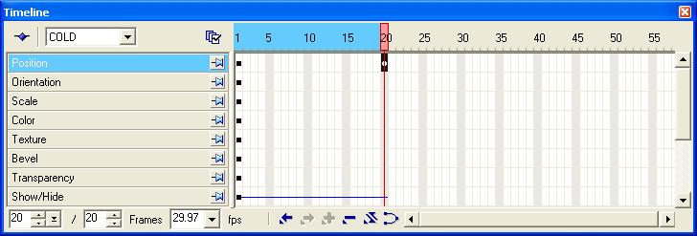

Figure 11
Expanded timeline

You should notice that the timeline has expanded its range over 20 frames now instead of the original 10. What this means is that the animation will run place a bit longer. Since the keyframes did not change their properties, we can expect the same animation as before, only smoother. See Figure 11 for the expanded timeline.

Play the animation again from the Navigation panel. As you can see the animation takes twice as long to complete because twice as many frames were interpolated. The only problem you should notice is that the playback is jumpy. This is because we’re set up to run at 15 frames per second (FPS). Television content runs at 29.97 frames per second. We can preview the animation at this rate by clicking on the Frames dropdown at the bottom of the Timeline panel. Select 29.97 from the list. This is also illustrated in Figure 11.

Play the animation once more. At first it will not appear to run at 29.97 frames per second. This is because the frames need to be rendered first. The animation will first play in a staggered fashion. When the animation completes, press the Play button again and the animation should run at 29.97 frames per second.

The animation looks great but we’re going to add some more effects to the text. Before we do this we need to add more frames to the animation. This isn’t the same as changing the duration, as we did before. For this we will pad frames after the last frame. Doing it this way will keep the keyframe at frame 20 in place but still giving us more frames to animate into. Right click on the timeline frame number labels and select Pad Frames from the list. When the dialog appears, type in 90 and click the After last frame radio button. Click OK and take notice that the timeline has expanded now to frame 110. This will provide enough room for the rest of our animations.

Text Effects
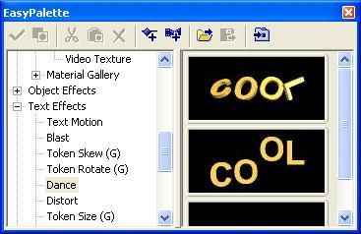

Figure 12
Dancing text effects
Playing the animation as it is now, you will see the “COLD” text come in from afar and sit still for about three seconds. COOL 3D provides a gallery of text effects for us to use. We will simulate the text shivering as if it were standing out on a cold day.

Click on the first frame in the Timeline panel. From the EasyPalette panel expand the Text Effects tree and select the Dance feature. After clicking on it some thumbnails with dancing animations should appear to the right. See Figure 12.

From the thumbnails, double click on the top most one. Doing this will add a new layer to the timeline, named Dance. It also added a keyframe to the last frame under the Dance layer. The first thing to do is delete that keyframe. Navigate to the last frame, select the keyframe in the Dance layer and press the button at the bottom of the panel that represents a minus sign ( - ). The keyframe should have been removed. All this means is that we’re going to use the same text effect over the entire animation; we do not plan on changing the dance animations properties while animating.

Click the first frame and then on the Dance layer. The Attribute Panel should have its contents changed to the customizable parameters for the Dance effect. You can experiment with these settings at your own pace. The values we’re going to use for this tutorial are:

Dance Mode: Shake
Sequence: All
Tempo: 10
Variation: 2
Seed: 30

After applying these values, run the animation again and you will notice that the text shakes, giving meaning to the word “COLD”.

Other Effects
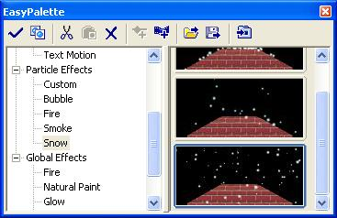

Figure 13
Snow particle effects
Effects offered by COOL 3D do not just range over text effects. There are scenery and particle effects that you can use for other situations. We’re going to add a final effect to our animation: snow.

Go back to the EasyPalette panel and expand the tree for Particle Effects, select Snow. From the thumbnails on the right, apply the bottom most icon, which shows snow blowing in from the left. See Figure 13.

The snow effect is considered a separate object from the text, with it’s own set of properties. Press the Play button again and watch the animation you created.

That concludes this tutorial. With everything you have learned, try to make animated text to represent a very hot day. You might want to consider using effects such as particle smoke, particle fire and a text wave to simulate the intensity of heat.

