Using COOL 3D as an Authoring Environment

A cost effective graphic authoring companion for ChyTV would be Ulead’s COOL 3D Production Studio. Using this software you can create three-dimensional graphics and animations for use directly on the ChyTV. This guide will show you how to use COOL 3D to create your logo as a 3D object.

Before getting started make sure you have Ulead COOL 3D Production Studio installed. You will also need either a vector or bitmap image of your logo. Files accepted by COOL 3D should be in AI, EMF, WMF, JPG or BMP formats. You will also need a slight knowledge of three-dimensional terms and techniques.

Start by loading COOL 3D. When the program begins you’ll be given a document window where you will be working. This window will default to 320 pixels wide by 240 pixels high. While working on the logo it would help to increase the document size (you can always change it later). From the application’s menu, select Project and then Dimensions. When the dimensions window appears, change the width to 640 pixels and the height to 480 pixels. Click OK and the document will be resized.

Importing Your Logo from a Vector Image

If you have a logo in vector format (AI, EMF, or WMF files) then click the button from the bottom of the left toolbar, labeled Import Graphics.

The vector data will be placed onto the canvas of the Path Editor window. If you can import the graphic this way, skip over the next section on importing from bitmaps.

Importing Your Logo form a Bitmap Image

If you do not have a logo in vector format, but do have it in a bitmap format (JPG or BMP files) then click the last button on the left toolbar labeled Convert to Vector. You will be asked to locate the file to convert.

After you select the file to be converted, you will be brought to a screen that asks for parameters in the conversion. It might be helpful to click the Show path only checkbox as doing so will allow you to see the paths of your logo more clearly. There are three different parameters for creating your initial set of vector paths: Tolerance, Jump point and Threshold.

Setting the Tolerance will affect how accurate the tracing of the image is when converting it to a vector format. Generally a lower tolerance setting will create a finer outline of the contrasting edges in the logo.

The Jump point determines how accurately the curves in your logo are portrayed when converted. A lower jump point will produce finer curves on your logo and make it look more realistic.

Threshold is the most important setting here as it will determine where on your image to create vector paths. The paths are defined by contrasts in luminance on your logo. A low threshold will define paths around parts of your logo which vary slightly in luminance whereas a high threshold will define paths around highly diverse luminance areas.

Once you make your adjustments to the tolerance, jump point and threshold click the OK button and your logo along with the vector paths defined in the conversion will be placed in the canvas of the Path Editor window.

Creating a 3D Object From Your Logo

Now that your logo has been loaded and converted to a vector format, you can take a look at the defined paths that will be used in creating the 3D object. Toggling the Show background checkbox will let you see these paths more clearly. It is important to note that a pair of closed path paths will define the body of the 3D object you are creating. This works by matching closed paths from the outside most inward as pairs.

Take a look at the images of the ChyTV logo and how it will convert to a 3D object. The paths from the original image are defined around four areas based on the default conversion parameters.

- Around the outside of the logo there is a thin black outline, the first path is the outer edge of this outline.
- The second path is the inner edge of the same outline.
- Around the blue body of the logo is another black outline, the third path is the outer edge of this outline.
- The last path is defined as an outline of the text “chyTV”

Accepting these paths will create a 3D object with a body composed of path segments (1, 2) and (3, 4).

 | 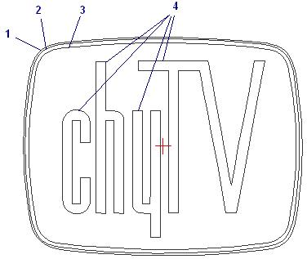 | 
ChyTV logo as a bitmap | ChyTV logo as four paths | ChyTV 3D segments (1, 2) and (3, 4),  highlighted in red
This 3D object that was created is now available for animating. While this object is not the true ChyTV 3D logo, the process that got us this result should be recognized.  It is important to note how the 3D object is created based on the paths you define. If the paths do not create the effect you wanted, the left toolbar provides some options for creating and manipulating paths. You could use those tools to design your 3D logo however you want it.  If the process outlined in this document did not provide a sufficient explanation as to how the paths define an object then take some time out to experiment with the paths at your own pace.  We will now create the true ChyTV 3D logo. It involves using the Path Editor and modifying the four paths created earlier. |  | 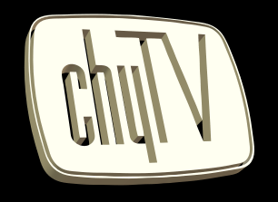
 |  | ChyTV 3D object

Creating the ChyTV 3D Logo

The problem with the last logo created is that it would prove too difficult or impossible to define all the detail and extrusions of the logo through just one object.  We need to create four distinct objects in order to give the ChyTV logo full detail and vibrancy. These objects are the body, the white outer frame, the dark grey outer frame and the chyTV text. We’re going to step through the process in creating these objects and putting them together to ultimately get the the 3D ChyTV logo that you see to the right.  Use the image in the previous section to reference the path numbers while they are being discussed in the creation process. | 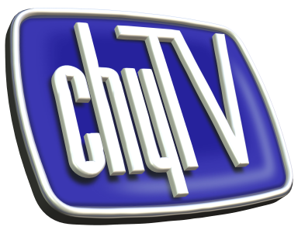

Creating the Body Object

Step 1
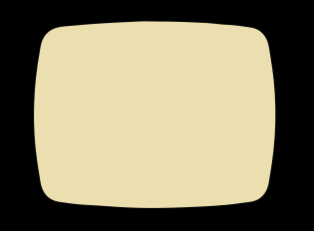

Figure 1
ChyTV body object
Get into the Path Editor by using the application’s menu Object and then Insert Graphics. Select the bottom button on the left toolbar, Import Graphics. Locate and open the chyTV_logo.jpg file. Accept the default conversion parameters and click OK.

To define the main body of the logo, we are going to delete paths 1, 2 and 4 from the Path Editor. Click on the second button from the top in the left toolbar, labeled Object. Now click on the first path, which is the outer most one, and click the delete icon (blue X) on the top toolbar. The path should have been removed from the canvas. Repeat this for paths 2 and 4. Remember that path 4 has four parts. Make sure you delete each one individually. With only path 3 remaining, click the OK button. A three-dimensional object will be placed in the document window, resembling Figure 1.

We will now name this object for later reference. From the application’s menu, select View then Toolbars Manager and then Object Manager… from the list. In the tool window that appears you will see an object named Graphic Object1 and it will be part of a group called [Group]. This group oversees all objects in the document and can be used to orient them simultaneously, much like a camera. Double click the Graphic Object1 object in the list, you can now rename it. Change the name to body and press Enter.

Step 2
Now we’ll set the properties of this object. This is the body of the logo, we want it to look nice. We have a bitmap of the logo on file so let’s apply the bitmap onto the object using texture mapping features of COOL 3D.
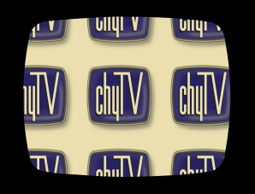

Figure 2
ChyTV initial texture mapping

From the Object Manager, make sure the body object is selected. From the Attribute Panel select Texture from the drop down list. The controls for texture mapping should have filled the Attribute Panel. You will notice four sections of controls for textures, wrapping, mapping and embossing.

Make sure the Image radio button is selected in the Texture section. Click on the Use checkbox and a dialog should appear asking you to locate the image file to map onto the object. Select the chyTV_logo.jpg file and click OK.

The body object will now display the ChyTV logo imagery on its face, see Figure 2.

Step 3
This step will be to scale and position the texture so that it covers the entire face of the object.
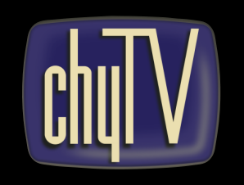

Figure 3
ChyTV adjusted texture mapping

In the Attribute Panel, go to the Mapping section and click on the Resize Texture button. Doing this will enable the controls for adjusting the X and Y scale of the texture across the object. Manipulate the values of the scale until you achieve a size that fits across the whole image. Note that smaller values will give you a wider scale.

You may need to adjust the position of the texture in order to size it perfectly. To change the texture position, click the Position Texture button and manipulate the X and Y values. Continue to play with the values of the position and scale until you can get something that looks like Figure 3. The following values were used to properly map the texture on the object.

Position: X = 203 Y = 139
Scale: X = 29 Y = 35

Step 4
We’re almost done with the body object. Right now the color of the “chyTV” text is incorrect. To change this color to white, select Color from the Attribute Panel dropdown. In the Surface color section, click on the button under Color and select a white from the popup dialog. Click OK and the text should now look white, similar to Figure 4.
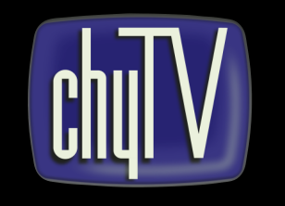

Figure 4
Final body object

We’re finished with the body object for now. If you rotate the object, you will notice the logo appears flat. In the next sections we’re going to give depth to the object by defining three more objects and adjusting their properties.

Creating the White Outer Frame Object

Step 1
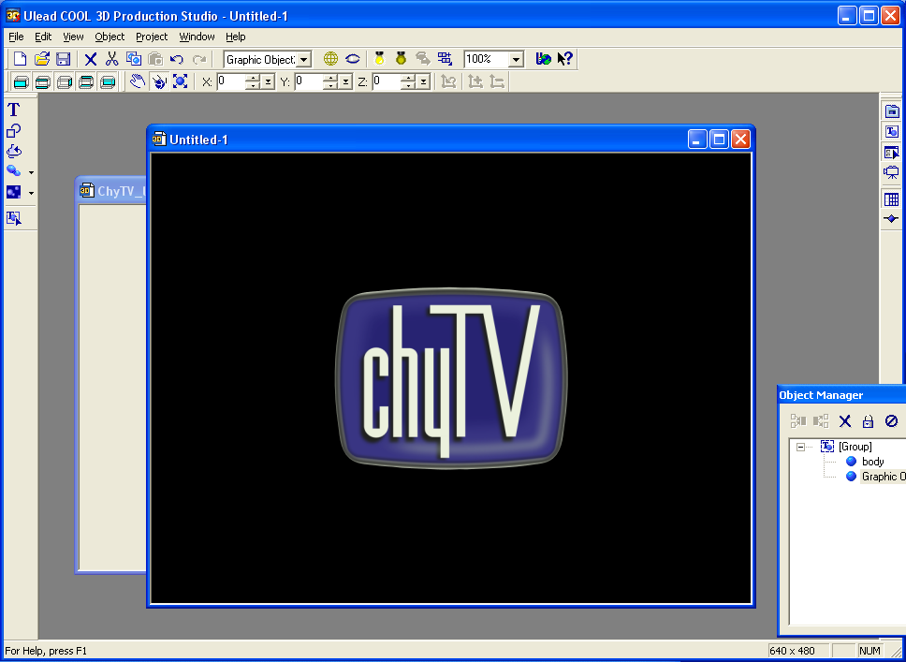

Figure 5
ChyTV object with a white outer frame
Make your way back into the Path Editor by using the application’s menu Object and then Insert Graphics. Select the bottom button in the left toolbar labeled Import Graphics. Locate and open the chyTV_logo.jpg file. Accept the default conversion parameters and click OK.

For this object we’re going to refer to the four paths mentioned earlier. This time we’re going to be deleting paths 1 and 4, leaving the representation of paths 2 and 3 on the editor’s canvas. Remember to delete all of path 4’s parts, as was done when preparing the body object.

With paths 2 and 3 remaining, click the OK button. A three-dimensional object will be placed in the document window, surrounding the body object. The document will resemble the image Figure 5.

Using the Object Manager rename this object to whiteFrame.

Step 2
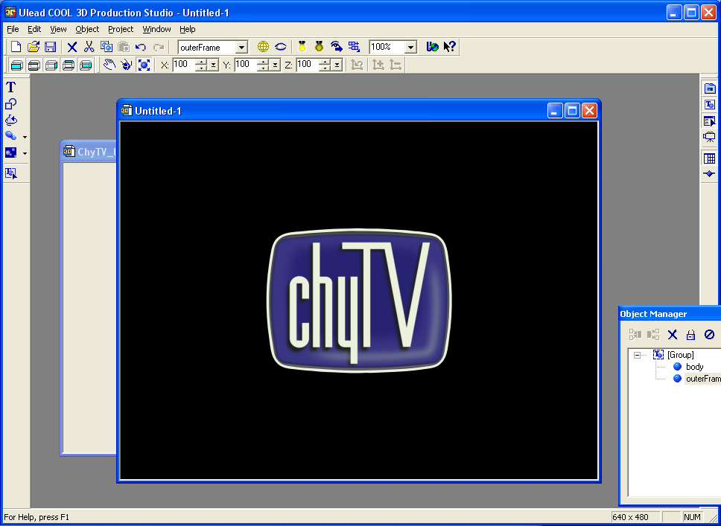

Figure 6
White outer frame after texture removal
Since we made this outer frame immediately after the body object, all of the body object texture and color properties were automatically applied to the new object. So what we’re going to do is to first disable the texture on the outer frame.

From the Attribute Panel, select Texture from the drop down list. Uncheck the Use checkbox under the Texture section. The color for this object should already be set to white. If it isn’t, you can change it to white by choosing the Color option from the drop down in the Attribute Panel. Your results should resemble Figure 6.

If you select the [Group] object and apply various rotations to it, you will notice that the whiteFrame object is flat and has the same depth as the body object. One last step to take on this object will be to give it a beveled look.

Step 3
Giving the whiteFrame object a beveled look will increase the realism conveyed by the logo. The tools to do this are located in the Attribute Panel if you select Bevel from the drop down.
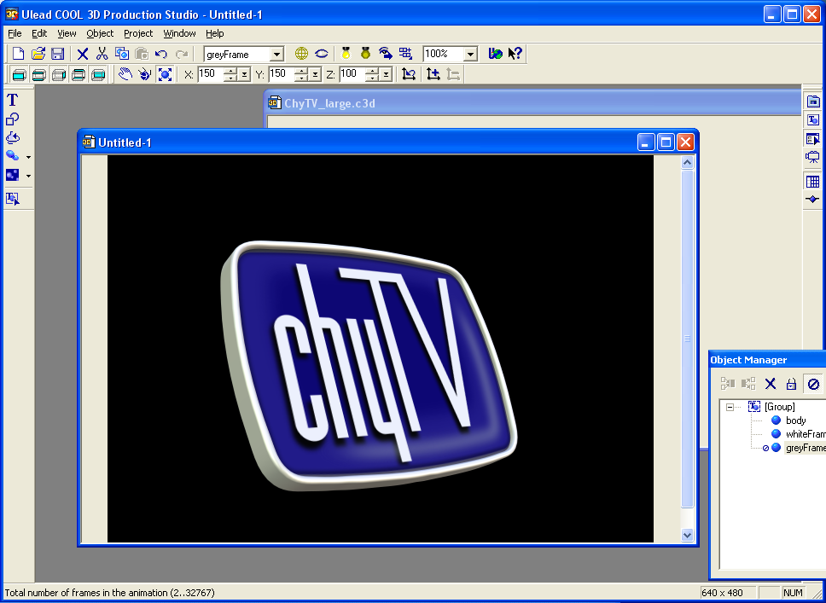

Figure 7
White outer frame after applying the bevel

There are different types of bevels available with COOL 3D and you can feel free to experiment with them all to get the effect you desire. For our logo we’re using the Round bevel, which can be selected from the Bevel mode section.

Each bevel type can be further configured in the fields of extrusion, weight, border, depth and precision. For information on what each of these fields represent, consult the help file for COOL 3D. Place the following values in the bevel fields.

Extrusion: 86
Weight: 5
Border: 12
Depth: 15
Precision: 3

In addition to the bevel, select the whiteFrame object and click the scale modification button on COOL 3D’s application toolbar. Adjust the Z value to 150. The whiteFrame object should have a slight curve on its face and extrude past the body object a bit, as is shown in Figure 7.

Creating the Dark Frame Object

Step 1
Make your way back into the Path Editor by using the application’s menu Object and then Insert Graphics. Select the bottom button in the toolbox labeled Import Graphics. Locate and open the chyTV_logo.jpg file. Accept the default conversion parameters and click OK.
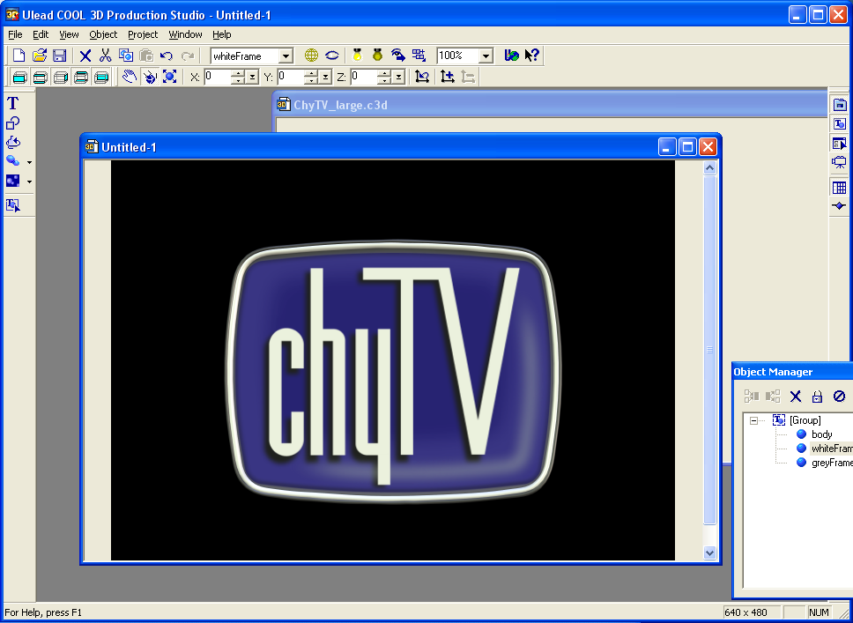

Figure 8
ChyTV object with a dark outer frame

For this object we’re going to refer to the four paths mentioned earlier. This time we’re going to be deleting paths 3 and 4, leaving the representation of paths 1 and 2 on the editor’s canvas. Remember to delete all of path 4’s parts, as was done when preparing the body object.

With path’s 1 and 2 remaining, click the OK button. A three-dimensional object will be placed in the document window, surrounding the body object and the whiteFrame object. Adjust the color of the object to a dark grey, RGB = (75,75,75). The document will resemble Figure 8.

Using the Object Manager rename this object to greyFrame.

Step 2
Next we’ll modify the bevel a bit so that it looks different from the whiteFrame object. From the Attribute Panel, select Bevel from the drop down and modify the values to the following:
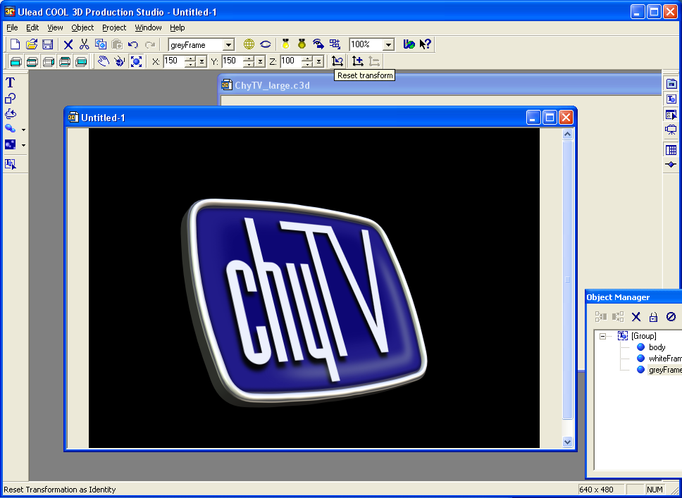

Figure 9
Dark outer frame after modifications

Extrusion: 100
Weight: 5
Border: 5
Depth: 10
Precision: 3

The entire object should now resemble Figure 9.

Creating the chyTV Text Object

Step 1
We’re almost finished designing the logo. The last two step are to have the “chyTV” text stand out more than it does right now. For this we’re going to make the text its own object.
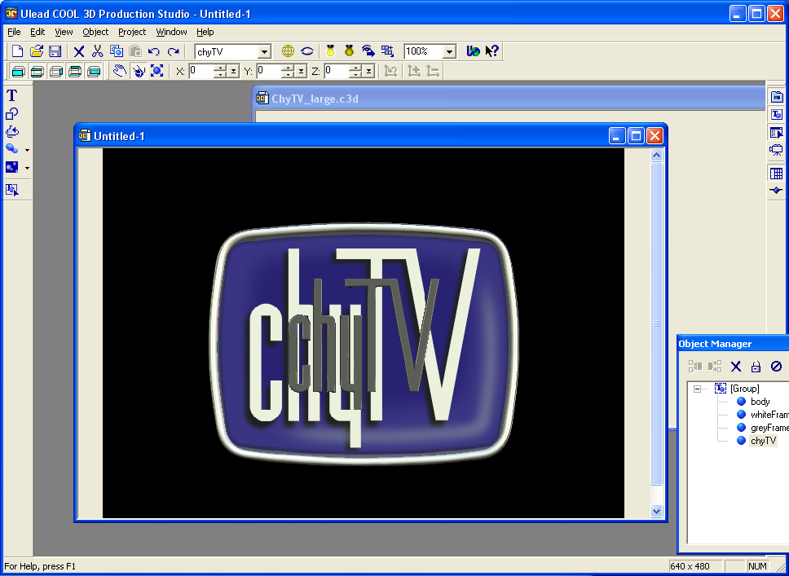

Figure 10
chyTV text before modifications

Go back into the Path Editor by using the application’s menu Object and then Insert Graphics. Select the bottom button in the toolbox labeled Import Graphics. Locate and open the chyTV_logo.jpg file. Accept the default conversion parameters and click OK.

For this object we’re going to refer to the four paths mentioned earlier. This time we’re going to be deleting paths 1, 2 and 3, leaving the representation of only path 4 on the editor’s canvas.

With only the parts of path 4 remaining, click the OK button. The “chyTV” text will be placed in the center of the document. Rename the object to chyTV. You will see something similar to Figure 10.

Step 2
The size of the text will not match the texture on the object. We need to adjust the X and Y scale values on the chyTV object until it covers the text displayed on the texture.
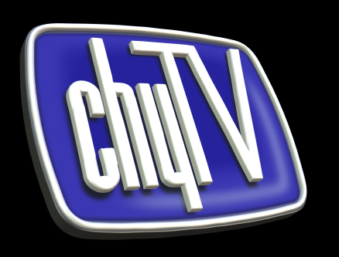

Figure 11
Final ChyTV 3D logo

Remember, the texture has no depth, so we made the text a 3D object to give it depth. Placing the 3D text directly over the texture will give the illusion that the text is popping out of the body object.

- Adjust the scale values on the chyTV to:
X = 103 Y = 102 Z = 200

- Adjust the position of the chyTV object to
X = 0 Y = -3 Z = 0
- Change the color of the object to white.
- Set the bevel for the object to:
Extrusion: 85
Weight: 5
Border: 5
Depth: 10
Precision: 3

The end product should appear as Figure 11. Now that you know how to create 3D objects from paths, try to convert your company’s logo into a 3D object.

